Matthew Young

CIS450

Lab05 – Passive Recon

**COMPANY NUMBER 1 Facebook –**

CEO: Mark Zuckerberg

CEO BDAY:05/14/1984

CEO EMAIL: [zuck@fb.com](mailto:zuck@fb.com)

CEO PHONE: 650-543-4800

CEO PHONE LOC: Palo Alto, CA 94301

CEO PHONE NOTE: Comments mention Spam calling from this number as well as this number being connected to hacked bank account transactions.

CFO: David Wehner

CFO EMAIL: UNKNOWN

CTO: Mike Schroepfer

CTO EMAIL: schroep@fb.com

HQ: 1601 Willow Rd. Menlo Park, CA 94025

**COMPANY NUMBER 2 Micron Technology –**

CEO: Sanjay Mehrota

CEO BDAY: 06/27/1958

CEO EMAIL: [sanjay.mehrota@micron.com](mailto:sanjay.mehrota@micron.com)

CEO PHONE: UNKNOWN

CEO PHONE LOC: UNKNOWN

CEO PHONE NOTE: N/A

CFO: Paul Marosvari

CFO EMAIL: [pmarosvari@micron.com](mailto:pmarosvari@micron.com)

CTO: UNKNOWN

HQ: 8000 South Federal Way Boise, ID 83707-0006

**COMPANY NUMBER 2 Micron Technology Screenshots:**

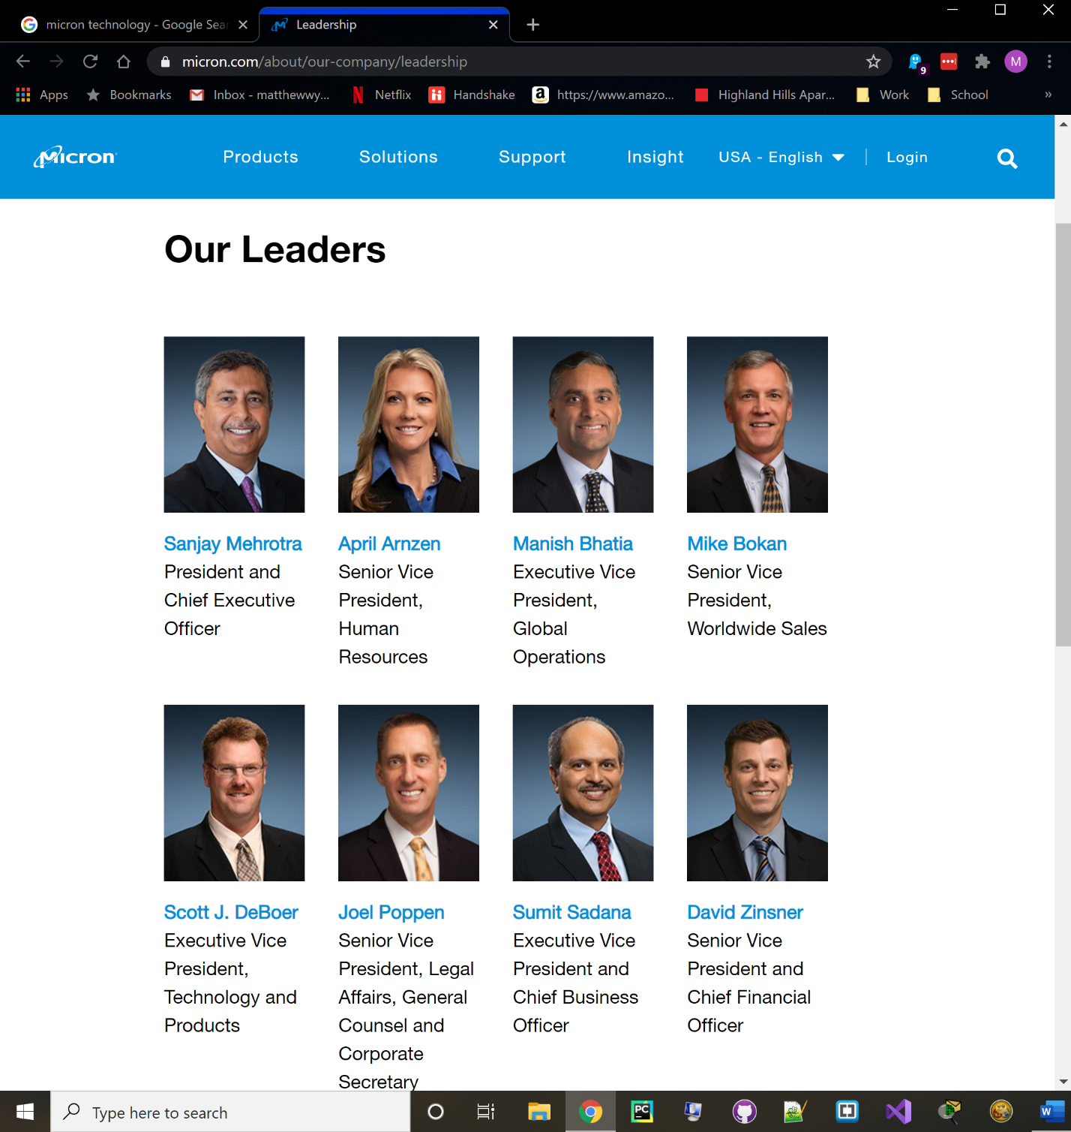

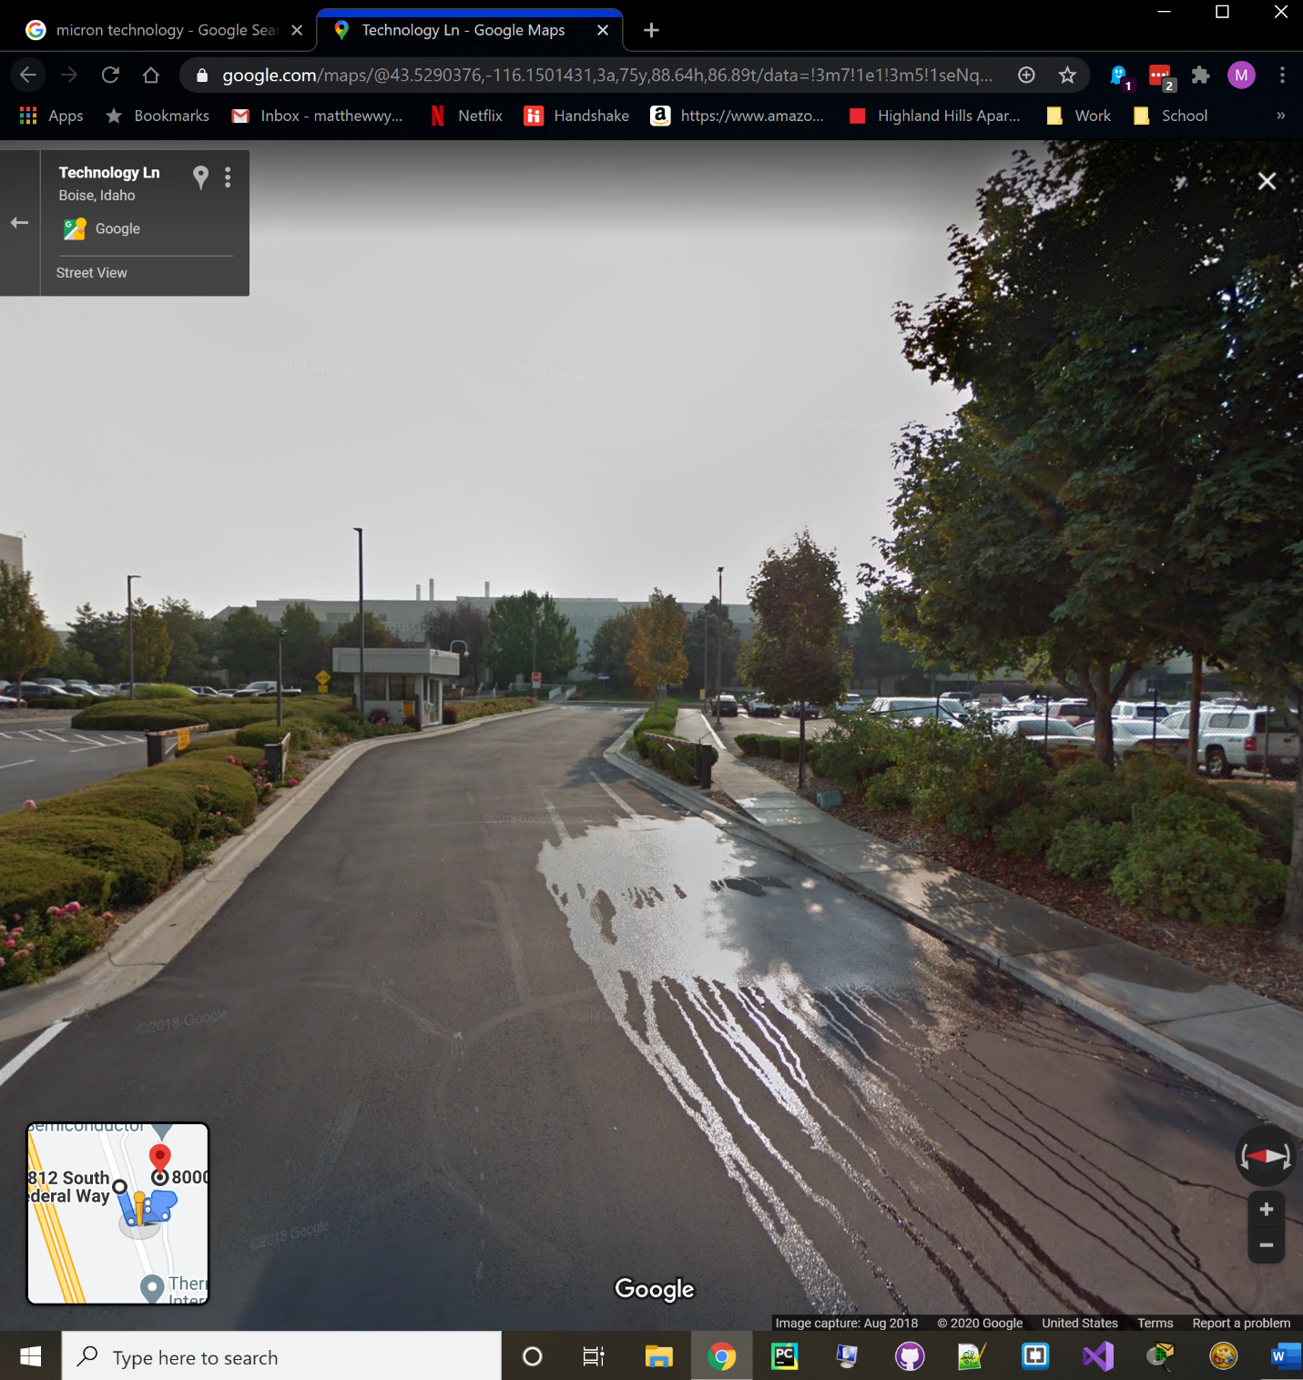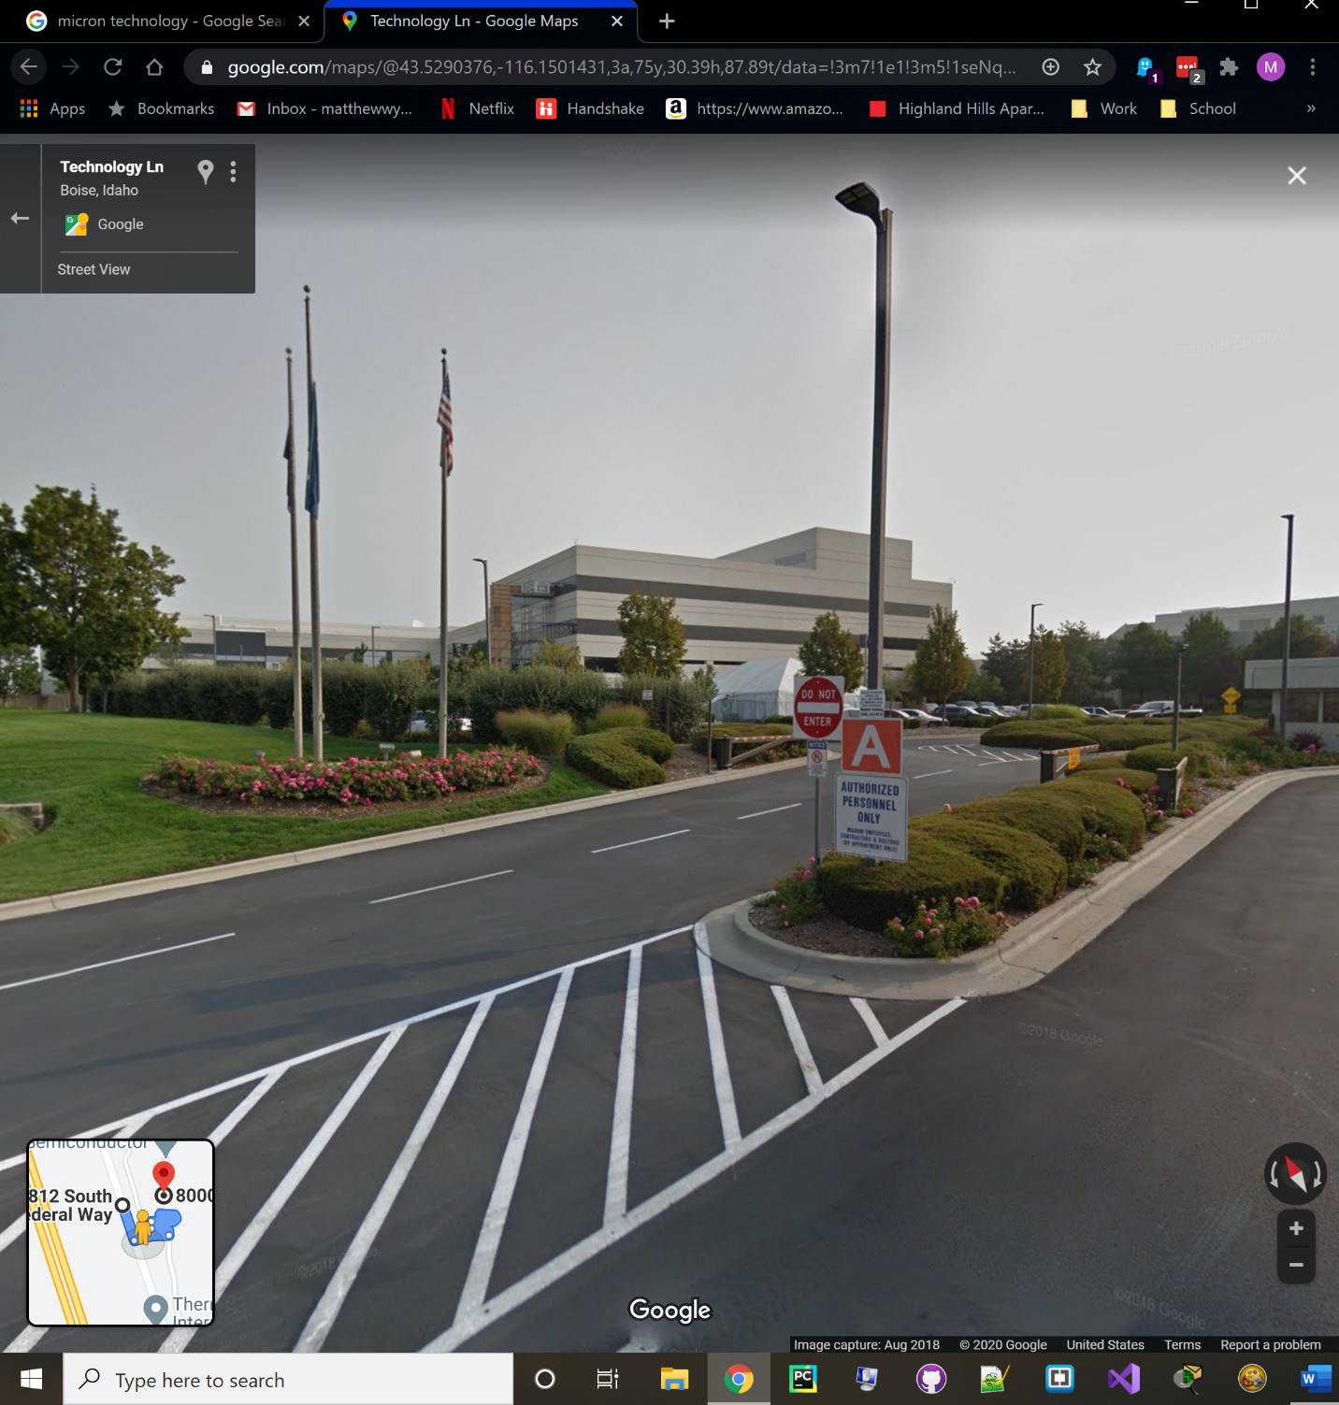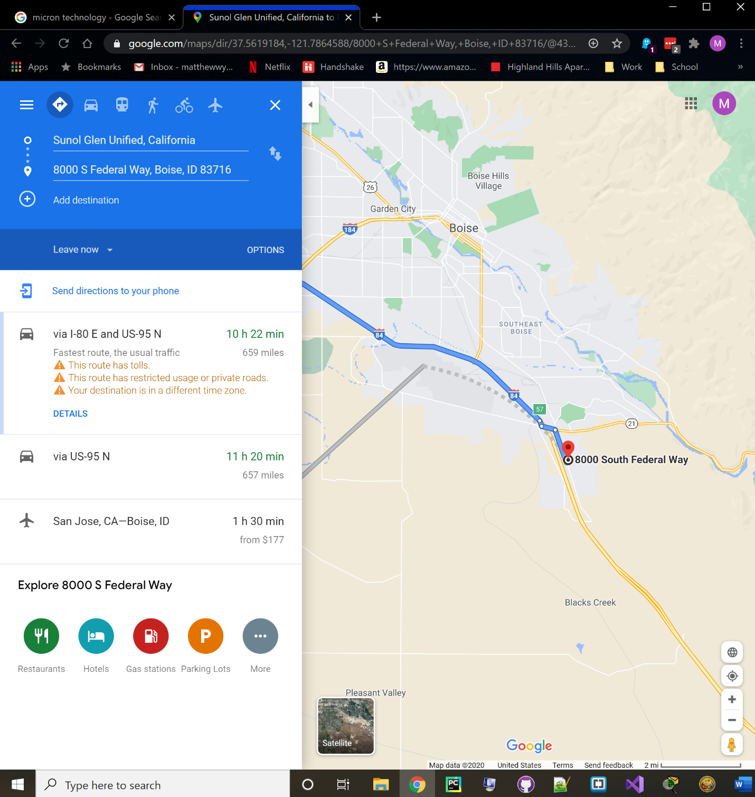

**COMPANY NUMBER 1 Facebook Screenshots:**

